Intermediate COCOMO Model
The basic Cocomo model assumes that the effort is only a function of the number of lines of code and some constants evaluated according to the different software system. However, in reality, no system’s effort and schedule can be solely calculated on the basis of Lines of Code. For that, various other factors such as reliability, experience, Capability. These factors are known as Cost Drivers and the Intermediate Model utilizes 15 such drivers for cost estimation.
Classification of Cost Drivers and their attributes:
(i) Product attributes –
- Required software reliability extent
- Size of the application database
- The complexity of the product

(ii) Hardware attributes –

- Run-time performance constraints
- Memory constraints
- The volatility of the virtual machine environment
- Required turnabout time

(iii) Personnel attributes –
- Analyst capability
- Software engineering capability
- Applications experience
- Virtual machine experience
- Programming language experience

(iv) Project attributes –
- Use of software tools
- Application of software engineering methods
- Required development schedule

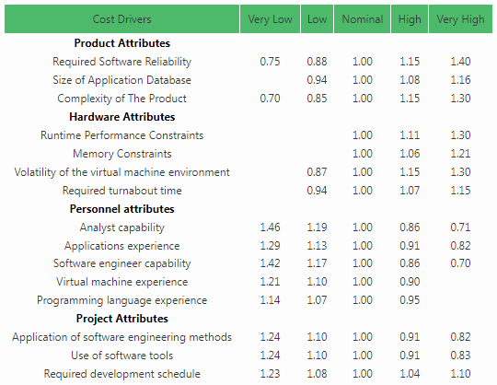

The project manager is to rate these 15 different parameters for a particular project on a scale of one to three. Then, depending on these ratings, appropriate cost driver values are taken from the above table. These 15 values are then multiplied to calculate the EAF (Effort Adjustment Factor). The Intermediate COCOMO formula now takes the form:
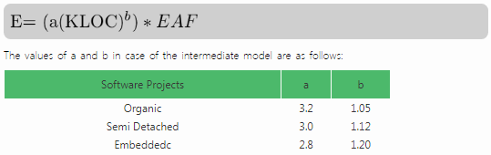

- Detailed Model –
Detailed COCOMO incorporates all characteristics of the intermediate version with an assessment of the cost driver’s impact on each step of the software engineering process. The detailed model uses different effort multipliers for each cost driver attribute. In detailed cocomo, the whole software is divided into different modules and then we apply COCOMO in different modules to estimate effort and then sum the effort.
The Six phases of detailed COCOMO are:
  - Planning and requirements
  - System design
  - Detailed design
  - Module code and test
  - Integration and test
  - Cost Constructive model
The effort is calculated as a function of program size and a set of cost drivers are given according to each phase of the software lifecycle.

